5.2 Diagonalization
Basis for $R^{n}$ that consists of eigenvectors of an matrix A, can be used to study geometric properties of A and to simplify various numerical computations. Such bases are also of physical significance in a wide variety of applications. Diagonalization of a Matrix A (if it is possible) can also be done using eigenvectors of the matrix A.

The Matrix Diagonalization Problem

Our first objective is to show that the following two seemingly different problems are equivalent.
Problem 1 Given an n×n matrix A, does there exist an invertible matrix P such that $P^{-1}AP$is diagonal?
Problem 2 Given an n×n matrix A, does A have n linearly independent eigenvectors?

Similarity
The matrix product $P^{-1}AP$ that appears in Problem 1 is called a similarity transformation of the matrix A. Such products are important in the study of eigenvectors and eigenvalues, so we will begin with some terminology about them.

DEFINITION 1
If A and B are square matrices, then we say that B is similar to A if there is an invertible matrix P such that ${B=P}^{-1}AP$.
Note that if B is similar to A, then it is also true that A is similar to B, since we can express B as ${B=Q}^{-1}AQ$ by taking ${Q=P}^{-1}$. This being the case, we will usually say that A and B are similar matrices if either is similar to the other.

Similarity Invariants
Similar matrices have many properties in common. For example, if ${B=P}^{-1}AP$, then it follows that A and B have the same determinant.
In general, any property that is shared by all similar matrices is called a similarity invariant or is said to be invariant under similarity. Table 1 lists the most important similarity invariants.
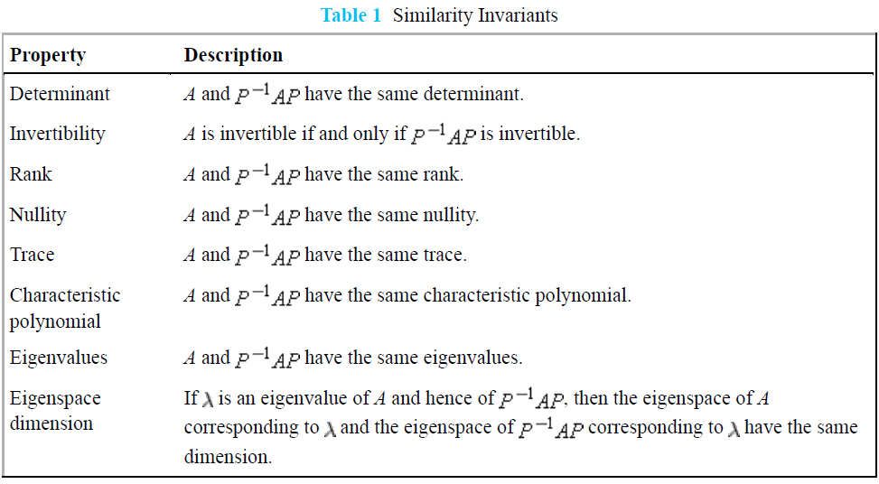

Expressed in the language of similarity, Problem 1 posed above is equivalent to asking whether the matrix A is similar to a diagonal matrix. If so, the diagonal matrix will have all of the similarity-invariant properties of A, but will have a simpler form, making it easier to analyze and work with. This important idea has some associated
terminology.

DEFINITION 2
A square matrix A is said to be diagonalizable if it is similar to some diagonal matrix; that is, if there exists an invertible matrix P such that $P^{-1}AP$ is diagonal. In this case the matrix P is said to diagonalize A.

THEOREM 5.2.1
If A is an matrix, the following statements are equivalent.
(a) A is diagonalizable.
(b) A has n linearly independent eigenvectors.

Procedure for Diagonalizing a Matrix

